

**Exeter Christian Reformed Church**

**332 Huron Street W.**

**Exeter, ON**

**N0M 1S1**

**August 5, 2025**

**Re: Pastor Kevin TeBrake Retirement.**

Dear Classis Huron,

Pastor Kevin teBrake has submitted a letter to Exeter CRC Council to request a recommendation to Classis Huron for him to granted retirement under Article 18. The council of Exeter Christian Reformed Church has very much appreciated the work of Pastor Kevin while he was here a Minister of the Word. We also see the blessing of his continued work bringing messages to many of the church in Classis Huron and hope he will be able to lead many Sunday services, weddings and Funerals.

We recommend to Classis Huron that Pastor Kevin teBrake be granted retirement under Article 18

and approved for Pastor Emeritus status. Exeter Christian Reformed Church will continue to hold his credentials.

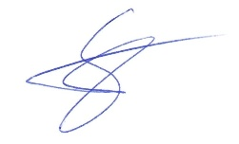

Gerard Steenbeek