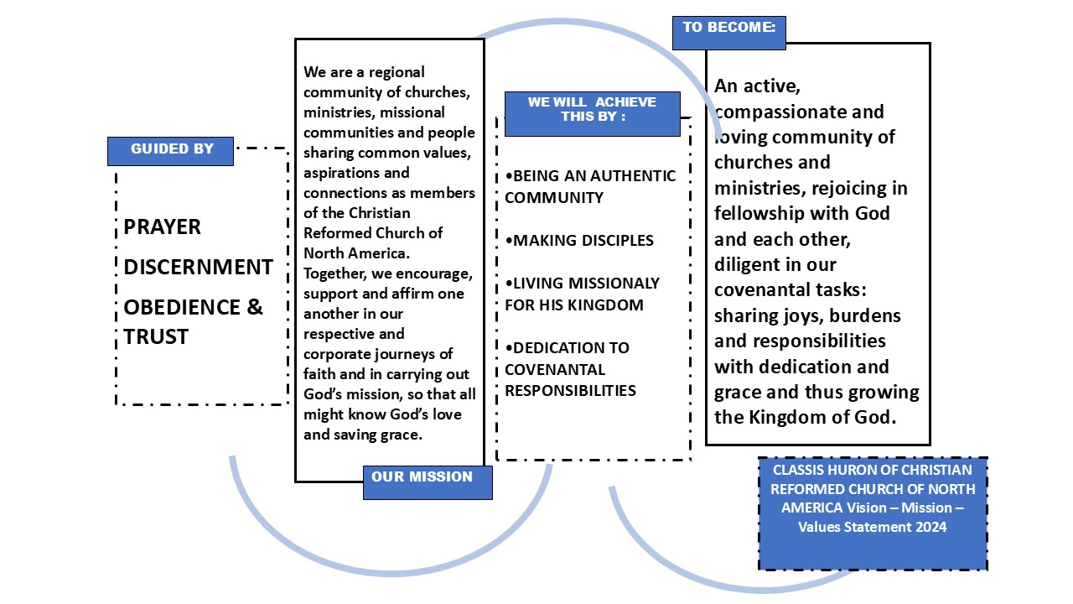

# INTRODUCTION

Article 75 of the CRCNA Church order includes the directive that “each Classis should create and implement a ministry plan that advances evangelistic and diaconal witness to Christ and his kingdom in its specific region.” Further reference to Article 75 suggests that “developing a plan for ministry is also an opportunity for a classis to explore and articulate its purpose and potential for renewal.” The CRCNA has developed a [denominational ministry plan](https://www.crcna.org/OurJourney) and various agencies and ministries have done the same.

Classis Huron, directed by the Classis Ministry Committee (CMC) began a classis ministry plan development process in 2022. The process included a number of facilitated consultations and a Classis wide strategy session followed by a CMC discernment session. All contributing insight and information were reported to subsequent Classis meetings and the final results presented at the February 19, 2025 Classis meeting for referral to member churches and ministries.

# VISION

A vision statement is an anchor point of any strategic/ministry plan. It outlines what the organization aims to accomplish and give it purpose. In the case of the Classis Huron Ministry Plan – we see our future within God’s plan: that His kingdom come and His will be done. A foundational question, that led the consultation process, was: “If Classis Huron were everything that God has called it to be and do – what would that look like?”

## Classis Huron Vision Statement

**Classis Huron is an active, compassionate and loving community of churches and ministries, rejoicing in fellowship with God and each other, diligent in covenantal tasks: sharing joys, burdens and responsibilities with dedication, grace and knowledge that …/thus growing the Kingdom of God. *(and celebration in the rise of God’s kingdom)***

# MISSION

A vision outlines what you would like to accomplish, while a mission statement details who you are, how you will achieve your mission and its intended impact. It is a concise statement that can be further articulated by developing strategy, goals and milestones.

## Classis Huron Mission Statement

**We are a regional community of churches, ministries, missional communities and people sharing common values, aspirations and connections as members of the Christian Reformed Church of North America. Together, we encourage, support and affirm one another in our respective and corporate journeys of faith and in carrying out God’s mission, so that all might know God’s love and saving grace.**

# VALUES

During the various consultation exercises with Classis Huron entities, common threads or principles appeared. Although, each group that participated had their own mandates and desired outcomes, each expressed a reliance on three core or transversal values, to be able to consider their role in God’s kingdom. These principles or foundational beliefs are to be incorporated and considered as we work within our mission, vision and strategy. They are vital, as Classis operates in sometimes complex situations and allow us to keep our identity and culture close.

## Classis Huron Core Values *(could use applicable bible verses here instead of summaries)*

**Prayer:** Prayer is our lifeline. We Praise and thank God, confess our wrongdoing and ask for His vision and His blessing on our actions and activities. We are assured that He will hear our prayers.

**Discernment:** God is already working within us and our community; we need to be attuned to His vision and joining as He calls us to.

**Obedience and Trust:** We are obedient and trusting in God’s vision, even in new spaces and uncomfortable places.

## STRATEGY

Goals and outcomes are explicit in the vision/mission of Classis Huron but they will need strategies to be actionable. A good strategy provides a clear roadmap, and a deliberate and thoughtful approach to achieve goals. Any strategy must consider the vision, mission and values of Classis Huron. Mission drift (diversion of resources/activities from original goals) can easily overwhelm and distract from our God-given mission.

The following priorities came from the initial consultations, extracted from the various conversations and results. They were also the focus of the broader Classis discussion that took each element and asked participants to brainstorm how/why it was necessary to achieve these priorities.

### Classis Huron Mission Plan Priorities/Goals

### Authentic Community

**Fellowship and caring for each other, knowing each other stories, successes and struggles are important to us. This will take meaningful conversations and being proactive in places of tension and change. It will mean sharing, listening, trust, respect and a reliance on Jesus in all things.**

### Discipleship

**We recognize that all are disciples, committed to growing in faith and becoming the persons God wants us to be. We are also committed to teaching, leading and demonstrating to others what it means to think, act and speak as followers of Christ. We actively seek out opportunities for learning and discussion, acknowledging that our youth and their discipleship are important to us – they are not just the Church of Tomorrow: they are the Church of Today! God can and does use them right now to impact their families and communities.**

### God’s Mission

**Every person is God’s child and deserves to know his saving grace. We leave the comfort of the fellowship of fellow believers to engage with those who do not know Christ, whether they be across town or on the other side of the globe. We do the work of Jesus Christ in the power of the Spirit. We pursue justice, reconciliation and peacemaking, serving others, caring for creation and giving as we are able. We will practice neighboring, loving our neighbors as ourselves.**

### Covenantal responsibilities and tasks

**We will meet our institutional and relational obligations in a way that the Lord can rejoice in: being diligent, being creative and sharing ideas and ideals in an environment of grace, love and respect. Together we celebrate life in the church, recognizing the rhythms of joy and sorrow, the beginning and end and the conversations that contribute to our understanding of all issues.**

# KEY ACTIONS (not listed in order of importance)

* Continued emphasis on balanced Classis Meetings: fellowship, prayer, learning, business
* Youth Catalyst position to give pastoral support to Youth Leaders (staff and volunteers) and catalyze growth/sustainability in church youth programs
* Leadership training in communication, conflict resolution, meeting governance and chairing
* Incorporate story-telling and sharing into process
* Renewed focus on Church Plants: their form, function and how to support our own Classis member and others in the task.
* Opportunities for mission trips and experiences
* Renovated Committee Structure

# BACKGROUND

## Process

The following activities contributed to the creation of the Classis Huron Ministry Plan. More detailed record of the various consultations and activities are available from Classis Huron Mission Catalyst: Joan Brady by [email](mailto:jbrady@crcna.org?subject=CH%20Ministry%20Plan%20) or on the [Mission Catalyst](https://classishuron.ca/mission-catalyzer/) page on the Classis Huron Website.

The activities occurred in a time period of 2022-2024 and were reported on at tri-annual Classis meetings

* Consultations
  + Classis Huron Mission Team
  + Classis Huron Youth Leaders
  + Classis Huron Diaconal Ministry Committee
  + Classis Huron Classical Ministries Committee (CMC)
* Roundtable Strategy Session at a Classis Meeting
* Final discernment session with CMC
* CMC Review and submission to Classis members

## Focus on Discernment

Each meeting was conducted with an intentional focus on discernment and prayer. Participants were invited to pray and to consider where God was leading the process. Special consideration was given to the various styles of learning and communication and acknowledging that each one in attendance was an important part of the process – brought by God to the conversation.

## Guiding Questions

1. **Contextual Analysis – What is the environment that we exist and operate in?**

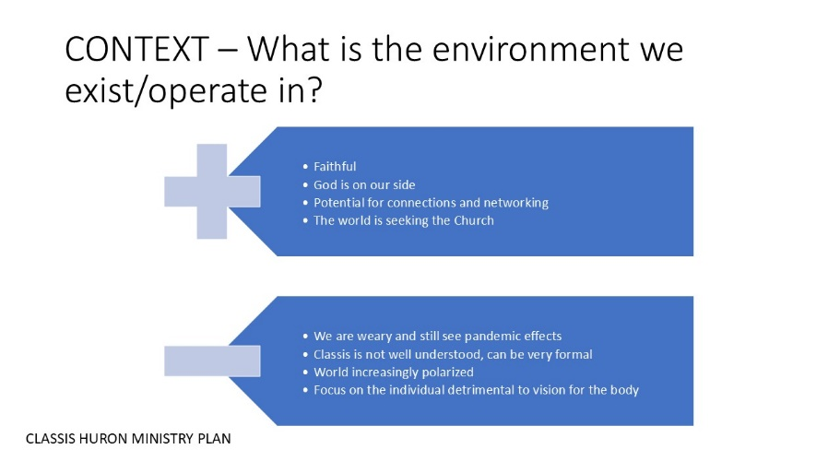Contextual analysis is the process of breaking down a complex issue or problem in order to better understand it. Contextual analysis can include the consideration of socio-cultural, political, economic and geographic factors that will influence the topic in question.

Each consultation incorporated a reduced version of contextual analysis, dealing with the positive and negative conditions that exist in the world, in Canada, in our communities and in our churches and denomination. Discussions were held in small groups or as a facilitated full group discussion. Further reflections included the consideration of contextual elements in the visioning process and the perspectives and realities that might exist. This exercise was helpful to set the stage for deeper discussions.

1. 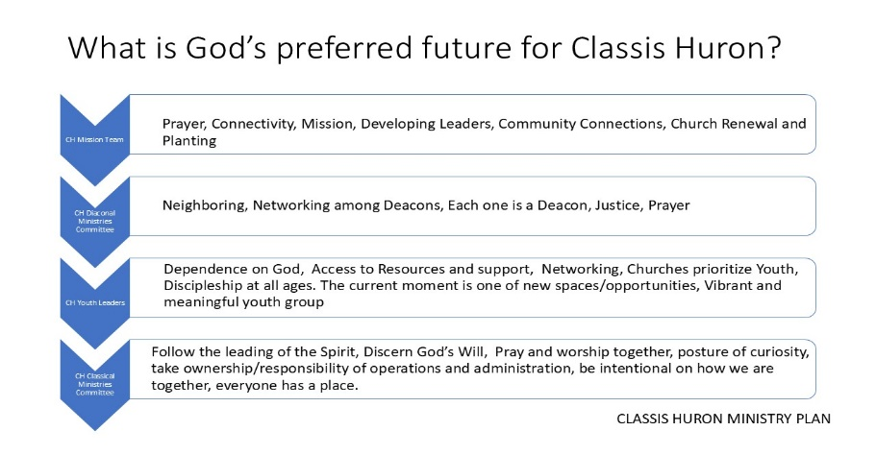If Classis Huron were everything that God has called it to be and do – what would that look like?

Participants were asked to list the qualities and activities that would be present in a God-honouring Classis. Each consultation emphasized from the role that they played in Classis (Diaconal Ministries Committee or Classis Youth Leaders, etc.). The results were recorded to provide detail to the ministry plan and combined to produce priority areas for further discussion.

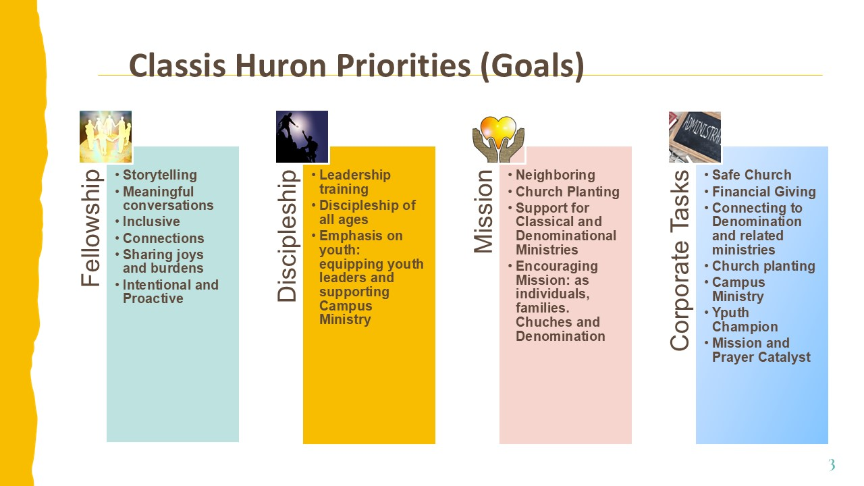

1. Logic Model or Theory of Change

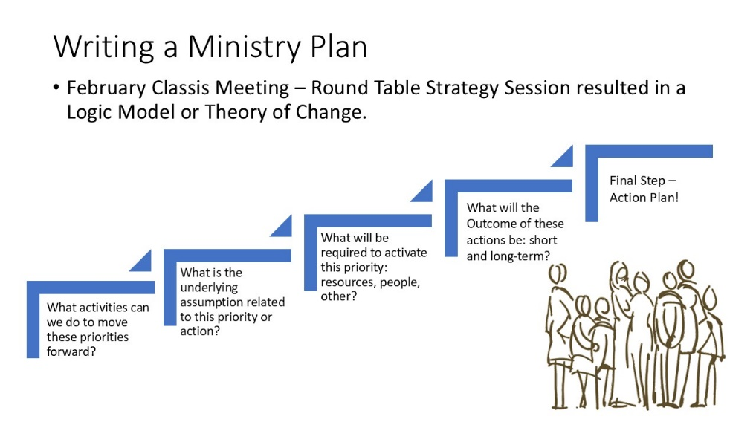A logic model or theory of change is a tool which can test the alignment of proposed or current activities with desired outcomes. It helps to clearly define, who and what the organization is, where it is going and how it is going to get there. In the creation of a Classis Huron Ministry Plan based on the mission/vision/values and stated priorities, a roundtable strategy session was held at the February 2024 Classis Meeting. Classis members were given the opportunity to discuss potential activities based on a series of structured questions related to the Theory of Change model.

THEORY OF CHANGE

**What We Heard about Fellowship and being an Authentic Community**

* Activities to increase connections and meaningful conversations/relationships both within Classis Meetings and between Classis members
* Cluster Churches to work/share in the journey together
* Shared retreats, events for Pastors and Leaders – beyond just Classis meetings
* Story Telling as part of opening devotions, be prepared to tell stories and record stories for further sharing
* Consider newcomers to Classis and to our Churches – be welcoming, tolerant and inclusive
* Respectful dialogue – posture of listening closely – questions asked to clarify – brave spaces that allow vulnerability
* Pray and worship together
* Being present – seeing first-hand Church Plants and other transformational places
* Classis sponsored networking re: youth ministry, diaconal, etc.
* Pulpit Supply as a time to share with each other about our congregations

**What We Heard about Discipleship**

* Offer Leadership, Evangelism and Neighboring Training – Discipleship focus
* Discipleship should be seen as a continuum – from child to adult
* Leadership training - survey leadership and address gaps in knowledge and understanding
* Priority on Youth - Financial support for a Classis Youth Catalyst to support youth ministry leaders and youth discipleship
* How do we engage our young members – get them to contribute ideas and leadership
* Mission Trips and other shared learning experiences created fellowship and growth in discipleship
* Mentorship
* Intentional succession – develop future leaders
* Intergenerational opportunities – learning from one another.

**What We Heard about Mission**

* Renewed focus on Church Planting – learn together, empower Church Planters, support all/other church plants.
* Support Churches consider hosting a church plant
* Neighboring – more focus on our outside community – Classis as a place to share experiences and learn new skills
* Resonate Go Local Workshop
* Mission Trips – create opportunities
* Connecting and supporting denominational ministries
* Storytelling and sharing our mission stories – churches supporting each other in their missional endeavors
* Find ways to make our churches/programs more accessible – go to where the people are rather than only in our spaces
* Participatory approach – everyone (deacons and community members) has something to contribute and together we build toward solutions – we have enough.
* Everyone is part of God’s mission

**What We Heard about our Covenantal Responsibilities and Tasks**

* New committee structure to make the most of our dedicated volunteers and connect our various areas of focus. (Thrive Model)
* Change the narrative on filling committee/AdCom/delegate positions as part of our Christian service – a privilege and responsibility
* New Ministry Share model – need better understanding/training
* Prioritize youth ministry and support youth leaders with CH Youth Catalyst
* Re-consider support needed for Campus Ministry – is it enough?
* Consider new approaches
* Classis meeting structure and content
* We have the resources/capacity/commitment to what we are called to do (as gifted by God)
* Reduce administration – increase fellowship

1. **CMC Review:**

**Define Classis Huron, its purpose, ways of working and perception of effectiveness**

* What is the impact of Classis on the individual member of a Church
* What is the effect of lack of consistency of attendees – do we set “annual terms”?
* Challenge of legalistic vs. being led by the Spirit
* Adapting to current cultural/societal changes – being in the world but not of the world
* What is the circle of influence – where should our energies/efforts be focused
* Seeing some progress/positive change: celebrations, accountability, prayer catalyst, better gender balance, diaconal lunches
* We can do it differently: Focus on Christ and love each other even if we disagree
* The challenge of paid vs volunteer position, some people with passion and expertise may need extra capacity to give
* Change takes time, consistency and repetition
* Ministry shares – are they well understood, what are the barriers
* What is the precedent for being able to speak in closed sessions (safe church/CHMT) – what do they bring to a discussion
* Need balanced meetings: business, fellowship, reports, story-telling

**How do we function within our priority areas and what updates should we consider? Note some points crossover/complement other priorities as well.**

* Classis Meetings
  + Needs to be a safe place – how do we respectfully disagree
  + What is the role/power of the chair – how well know are Robers’ Rules or the Overture process
  + Explain how we work – consider the listener and first-time attendee
  + Need to be proactive to places of tension – what kind of training is required
  + Take the temperature of the room – how is everyone doing? What more/less is needed
  + Prayer and other round tables have been successful
* Discipleship
  + Equip us – what kind of training is required to understand impact and implementation of Synod decisions
  + Consider listening circles to promote skills of understanding and empathy
  + Develop action steps with an opportunity to report back and build the process
  + Hear the voices of youth – what do they need – acknowledge those impactful moments of faith formation such as SWIM/Serve/Mission Trips
  + Youth as shadow office bearers – how do we connect to the youth retreat?
* Mission
  + Church Planting: do we have a post-mortem of the Journey? What role could/should have Classis played.
  + Planter succession as an issue for ongoing sustainability – how do we separate church from the planter
  + Church Planting is not an easy journey – in Classis there has been mixed support re: Vital Point, River facilities grant
  + New Classis conversation about church planting – how it looks different now – missional communities, etc.