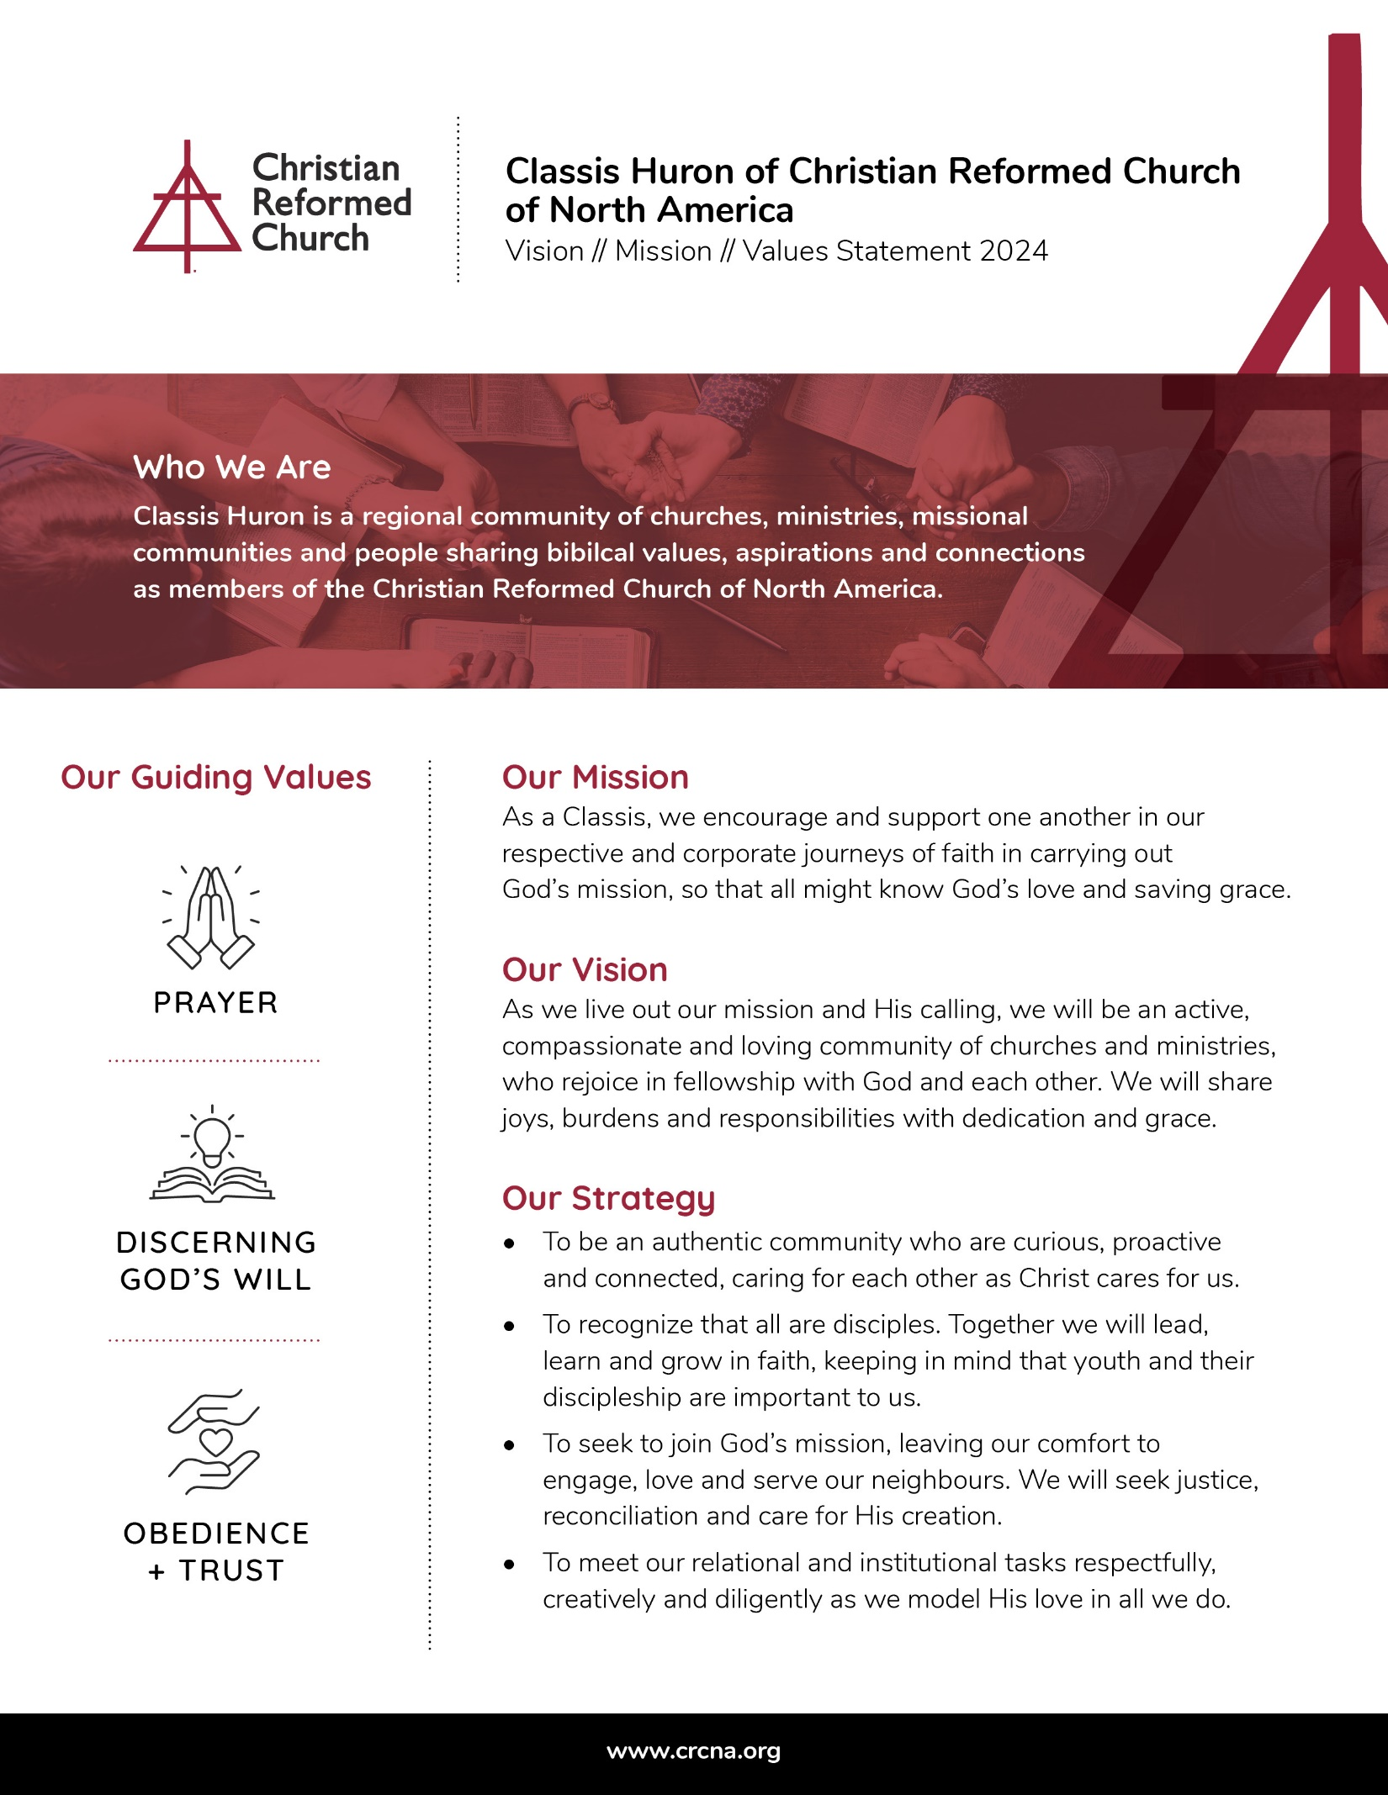

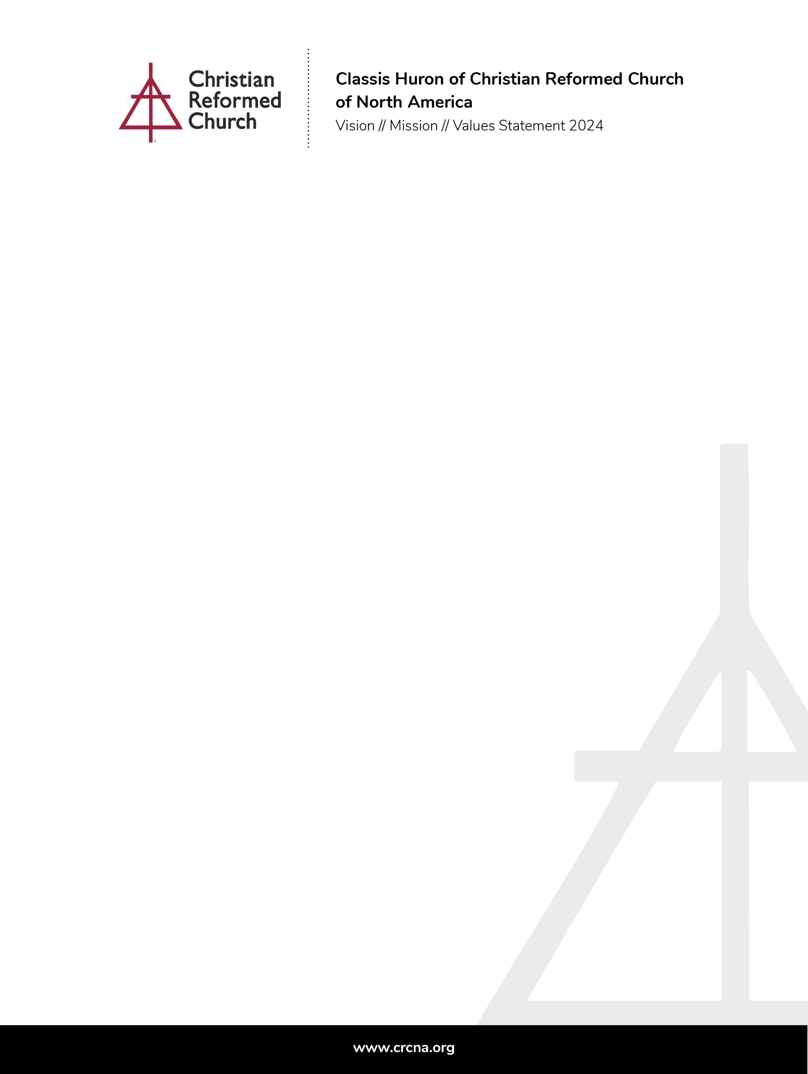

INTRODUCTION

Article 75 of the CRCNA Church order includes the directive that “each Classis should create and implement a ministry plan that advances evangelistic and diaconal witness to Christ and his kingdom in its specific region.” Further reference to Article 75 suggests that “developing a plan for ministry is also an opportunity for a classis to explore and articulate its purpose and potential for renewal.” The CRCNA has developed a [denominational ministry plan](https://www.crcna.org/OurJourney) and various agencies and ministries have done the same.

Classis Huron, directed by the Classis Ministry Committee (CMC) began a classis ministry plan development process in 2022. The process included a number of facilitated consultations and a Classis wide strategy session followed by a CMC discernment session. All contributing insight and information were reported to subsequent Classis meetings and the final results presented at the May, 2025 Classis meeting for referral to member churches and ministries.

VISION

A vision statement is an anchor point of any strategic/ministry plan. It outlines what the organization aims to accomplish and give it purpose. In the case of the Classis Huron Ministry Plan – we see our future within God’s plan: that His kingdom come and His will be done. A foundational question, that led the consultation process, was: “If Classis Huron were everything that God has called it to be and do – what would that look like?”

**Classis Huron Vision Statement**

**As we live out our mission and His calling, Classis Huron will be an active, compassionate and loving community of churches and ministries, who rejoice in fellowship with God and each other. We will share joys, burdens and responsibilities with dedication and grace.**

MISSION

A vision outlines what you would like to accomplish, while a mission statement details who you are, how you will achieve your mission and its intended impact. It is a concise statement that can be further articulated by developing strategy, goals and milestones.

## **Classis Huron Mission Statement**

**Classis Huron is a regional community of churches, ministries, missional communities and people sharing biblical values, aspirations and connections as members of the Christian Reformed Church of North America. As a Classis, we encourage and support one another in our respective and corporate journeys of faith and in carrying out God’s mission, so that all might know God’s love and saving grace.**

VALUES

During the various consultation exercises with Classis Huron entities, common threads or principles appeared. Although, each group that participated had their own mandates and desired outcomes, each expressed a reliance on three core or transversal values, to be able to consider their role in God’s kingdom. These principles or foundational beliefs are to be incorporated and considered as we work within our mission, vision and strategy. They are vital, as Classis operates in sometimes complex situations and allow us to keep our identity and faith close.

## **Classis Huron Core Values**

**Prayer:** Prayer is our lifeline. We Praise and thank God, confess our wrongdoing and ask for His vision and His blessing on our actions and activities. We are assured that He will hear our prayers.



**Core Values Con.**

**Discernment:** God is already working within us and our community; we are attuned to His vision and join as He calls us to. We seek his will

**Obedience and Trust:** We are obedient and trusting in God’s vision, even in new spaces and uncomfortable places.

STRATEGY

Goals and outcomes are explicit in the vision/mission of Classis Huron but they will need strategies to be actionable. A good strategy provides a clear roadmap, and a deliberate and thoughtful approach to achieve goals. Any strategy must consider the vision, mission and values of Classis Huron. Mission drift (diversion of resources/activities from original goals) can easily overwhelm and distract from our God-given mission.

The following priorities came from the initial consultations, extracted from the various conversations and results. They were also the focus of the broader Classis discussion that took each element and asked participants to brainstorm how/why it was necessary to achieve these priorities.

### Classis Huron Mission Plan Priorities/Goals

**Authentic Community:** Fellowship and caring for each other, knowing each other stories, successes and struggles are important to us. This will take meaningful conversations and being proactive in places of tension and change. It will mean sharing, listening, trust, respect and a reliance on Jesus in all things.

**Key Actions (not a complete list)**

* We will engage in activities to increase connections and meaningful conversations both within Classis meetings and between Classis members. We will cluster churches to work/share in the journey together
* We will continue to emphasis balanced Classis Meetings including fellowship, prayer, learning, storytelling and tasks
* We will consider newcomers and guests to Classis and our churches – be welcoming, tolerant and inclusive
* We will be present – seeing first hand Church Plants and other transformational places
* We will engage in respectful dialogue, a posture of listening closely and curiosity. We will create brave spaces that allow vulnerability
* We will sponsor Classis-wide networking with a focus on youth ministry, diaconal ministries, etc.
* We will encourage Pulpit supply as a time to share with each other about our congregations

**Discipleship:** We recognize that all are disciples, committed to growing in faith and becoming the persons God wants us to be. We are also committed to teaching, leading and demonstrating to others what it means to think, act and speak as followers of Christ. We actively seek out opportunities for learning and discussion, acknowledging that our youth and their discipleship are important to us – they are not just the Church of Tomorrow: they are the Church of Today! God can and does use them right now to impact their families and communities.

**Key Actions (not complete list)**

* We will offer leadership, evangelism and neighboring training with a discipleship focus
* We will consider discipleship as a continuum – from child to adult and support programing accordingly
* We will make youth a priority – beginning with financial support for a Classis Youth Catalyst to support youth Ministry leaders and youth discipleship
* We will encourage youth to contribute to vision and leadership and create intergenerational learning experiences
* Encourage mission trips and other shared learning experiences to create fellowship and growth



In your unfailing love you will lead the people you have redeemed. In your strength you will guide them to your holy dwelling.

Exodus 15:13 NIV

**God’s Mission:** Every person is God’s child and deserves to know his saving grace. We leave the comfort of the fellowship of fellow believers to engage with those who do not know Christ, whether they be across town or on the other side of the globe. We do the work of Jesus Christ in the power of the Spirit. We pursue justice, reconciliation and peacemaking, serving others, caring for creation and giving as we are able. We will practice neighboring, loving our neighbors as ourselves.

**Key Actions (not complete list)**

* We will renew our focus on Church Planting – learn together and empower Church Planters within Classis and elsewhere within the denomination
* We will promote neighboring and focusing on our respective outside community. Classis is a place to share experiences and learn new skills
* We will connect to and support denominational ministries – locally, nationally and internationally
* We will take a participatory approach – everyone, especially our community members with lived experience, has something to contribute and together we build toward solutions
* God is working in our communities – let’s get out and see
* We will support Campus Ministries and their focus on equipping students for a life of faith and Christian leadership.

**Covenantal responsibilities and tasks:** We will meet our institutional and relational obligations in a way that the Lord can rejoice in: being diligent, being creative and sharing ideas and ideals in an environment of grace, love and respect. Together we celebrate life in the church, recognizing the rhythms of joy and sorrow, the beginning and end and the conversations that contribute to our understanding of all issues.

**Key Actions (not complete list)**

* We will renovate Classis committee structures to make the most of dedicated volunteers and connect our various areas of focus
* We will honour the Ministry Share model – offering training, support and awareness as needed
* We will consider new approaches, streamline administration and increase fellowship
* We have the confidence that we have the resources/capacity/commitment to do what God has called us to do
* We will change the narrative of filling Classis committee/delegate/leadership positions – called and gifted to serve

- - April 2025 - - This is a living document and should be reviewed and updated on a regular basis - -